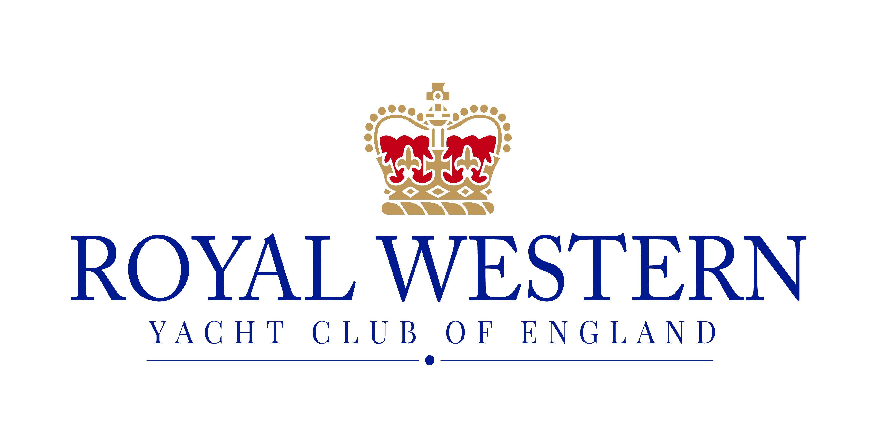

Sprint 15 Traveller

NOTICE OF RACE

18th – 19th August 2018

Organising Authority: Royal Western Yacht Club of England Ltd, PLYMOUTH, UK

Sprint 15 Traveller

Saturday 18th - Sunday 19th August 2018

Notice of Race

- ORGANISING AUTHORITY
1.1 The Organising Authority is the Royal Western Yacht Club of England.

- RULES
  - The traveller will be governed by the rules as defined in The Racing Rules of Sailing, RYA Prescriptions, current class rules and the Sailing instructions for the event.
  - Where boats are racing within the boundaries of the Port of Plymouth they are referred to the Dockyard Port of Plymouth Order 1999, a copy of which is displayed on the website (https://www.gov.uk/government/groups/qhm-plymouth) and Local Notices to Mariners. When the Race Committee believes that such regulations have been broken so as to bring the sport into disrepute it will act under RRS 60.2(c) requesting the Protest Committee to act under RRS 69.1(a), Allegation of Misconduct. Failure to comply with instructions from the Race Committee may result in a boat being scored DSQ.
  - Racing rules will be changed as follows. The changes will appear in full in the sailing instructions. The sailing instructions may also change other racing rules.
    - RRS 40 – Dinghy competitors shall wear personal flotation devices at all times whilst afloat.
    - RRS 44.1 – The Two - Turns Penalty is replaced by the One - Turn Penalty.
  - The exoneration penalty and Arbitration Procedures of the RYA will be available at this event.
  - Where there is conflict between the Notice of Race and the Sailing Instructions, the Sailing Instructions shall prevail except that neither shall change nor alter a class rule.

- ADVERTISING
  - No restrictions, but all advertising must comply with World Sailing Regulation 20, Advertising Code.

- ELIGIBILITY AND ENTRY
  - Entry is open to all Sprint 15 catamarans
  - All catamarans must be fitted with a strop to assist in the righting of the capsized boat. [DP].
  - Competitors may enter by completing an entry form available on the Royal Western Yacht Club of England website.

- ENTRY FEES & STORAGE
  - All Dinghies £30
  - This includes car parking at the marina- put car registration on entry form.

- SCHEDULE & FORMAT OF RACING
  - Registration will be held at the Race Office from 09:30 am on Saturday 18th August 2018.
  - There will be a competitor briefing at 10:30 am on Saturday in the RWYC clubhouse.
  - The traveller will consist of a maximum of 6 races.
  - Three back-to-back races are scheduled for each day. A maximum of four races may be sailed on any day. The scheduled time of the warning signal for the first race is 11:55 on Saturday and 10:25 on Sunday.
  - No warning signal will be made after 14:30 on Sunday.

- SAILING INSTRUCTIONS
  - Sailing Instructions
    - The sailing instructions will be published on the RWYC Website: http://rwyc.org/ no later than Friday 17th August.
    - Printed copies may be collected from the Regatta Office at registration

- REGATTA OFFICE
  - The Regatta Office will be located at the Royal Western Yacht Club
  - The Regatta Office will be open between the following times:
Saturday 14th October 0900 – 1800
Sunday 15th October 0900 – 1700
  - The Official Noticeboard (ONB) will be on the noticeboard in the clubhouse, notices may also be posted on the RWYC website.

- VENUE
  - The racing area for the traveller will be Plymouth Sound. Refer Admiralty Chart 30: Plymouth Sound and Approaches. Please also see Appendix 1 for Plymouth Sound Race Marks

- COURSES
  - The course will be from the Start Line, around the Marks for the required number of laps and then to the finish line. The course will be to port.

- SCORING
  - Each boats score shall be the total of her race scores less one discard for each 3 races sailed
  - A boat that did not start (DNC, DNS, OCS), did not finish (DNF), retired after finishing (RAF) or is disqualified under rule 30.3 (BFD) shall be scored points for the finish place one more than the number of boats that competed in the race. A boat that was disqualified other than under rule 30.3 (DSQ, DNE or DGM) shall be scored points for the finishing place one more than the number of boats entered in the series.

- PRIZES
  - A day prize giving will be held at the Royal Western Yacht Club at 1900 on Saturday 18th August 2018
  - The day and overall prize giving will be held at the Royal Western Yacht Club after the final race on Sunday 19th August 2018

- FURTHER INFORMATION
  - For further information relating to accommodation, catering etc., please refer to the RWYC web site (rwyc.org) or telephone: 01752 660077.

- RISK STATEMENT
  - Rule 4 of the Racing Rules of Sailing states: “The responsibility for a boat’s decision to participate in a race or to continue racing is hers alone.”
  - Sailing is by its nature an unpredictable sport and therefore inherently involves an element of risk. By taking part in the event, each competitor agrees and acknowledges that:
    - They are aware of the inherent element of risk involved in the sport and accept responsibility for the exposure of themselves, their crew and their boat to such inherent risk whilst taking part in the event;
    - They are responsible for the safety of themselves, their crew, their boat and their other property whether afloat or ashore;
    - They accept responsibility for any injury, damage or loss to the extent caused by their own actions or omissions;
    - Their boat is in good order, equipped to sail in the event and they are fit to participate;
    - The provision of a race management team, patrol boats and other officials and volunteers by the event organiser does not relieve them of their own responsibilities;
    - The provision of patrol boat cover is limited to such assistance, particularly in extreme weather conditions, as can be practically provided in the circumstances.

- INSURANCE
  - Each participating boat shall be insured with valid third party liability insurance. With a minimum cover of 2 million pounds.

- FURTHER INFORMATION
  - For further information please contact The Royal Western Yacht Club,
Email: hannah@rwyc.org
Phone: 01752 660077
  - The Clubhouse will be open from 08.30.
Bacon Rolls and hot drinks will be available!
Food will be available in the club after racing on Saturday
The bar will be open from 0900 to at least 2200.

A useful website to find accommodation is https://www.visitplymouth.co.uk/accommodation/hotels the nearest hotel to the yacht club is a Premier Inn at Sutton Harbour - https://www.premierinn.com/gb/en/hotels/england/devon/plymouth/plymouth-city-centre-sutton-harbour.html

APPENDIX 1
The marks are to be rounded to port,
Mark 1 is the intended windward mark.
Mark 4 will be laid in line with the windward mark.

The diagram indicates the number of legs required to complete each round. It does not indicate the angle between legs. The full course will comprise the number of rounds displayed on a board on the committee boat before a warning signal.

Boats must go through the start/finish line between each round.

