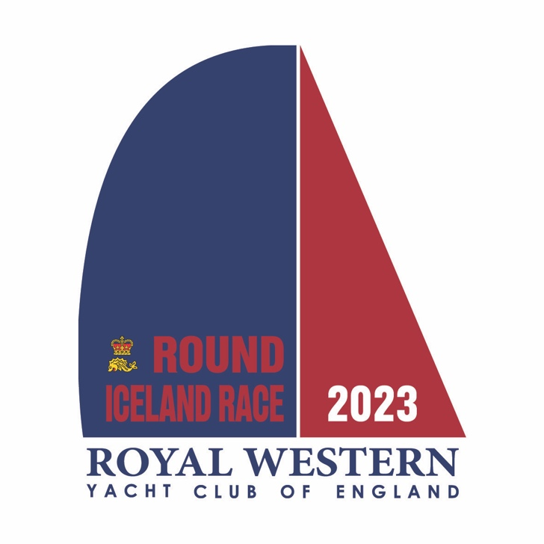

The Round Iceland Race
2023

Key Dates

01 January 2021 Qualifying passage period starts
01 March 2023 Discounted entry fee period ends
01 May 2023 Entries close
01 May 2023 Qualifying passage period ends
01 May 2023 Submit IRC/ MOCRA Certificates
01 May 2023 Last date for full entry fee payment
10 May 2023 Boats berthed in Plymouth
14 May 2023 1200BST Race starts
29 June 2023 2359GMT Race ends

