THE ROYAL WESTERN YACHT CLUB OF ENGLAND

The RWYC
LONELY ROCK RACE
2022

SOLENT - FASTNET ROCK - PLYMOUTH

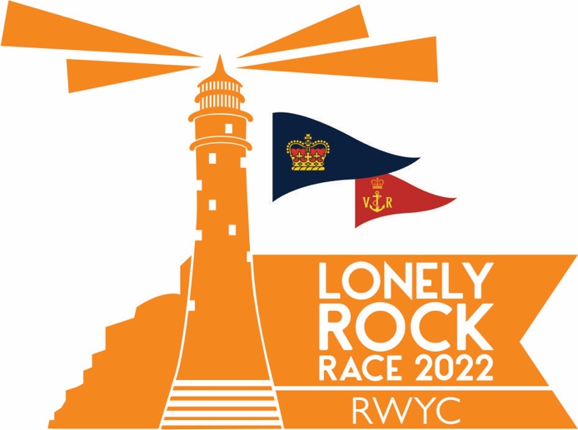

SAILING INSTRUCTIONS

SUNDAY 17th July 2022
14:00 BST
In association with the Royal Victoria Yacht Club

The Royal Western Yacht Club of England Ltd. - Queen Anne’s Battery - Plymouth PL4 0TW
Secretariat: 01752 660077 admin@rwyc.org www.rwyc.org
RWYC LONELY ROCK RACE 2022 SAILING INSTRUCTIONS
The responsibility for a boat’s decision to participate in a race or to continue racing is hers alone.
(RRS Fundamental Rule 3)
- ORGANISATION
The Organising Authority (OA) is the Royal Western Yacht Club of England (RWYC) in association with the Royal Victoria Yacht Club.
- OBJECT
The Race is intended to be a sporting event and to provide a sailing challenge to Corinthian sailors over a traditional course. A test of skill and endurance; safer by modern design, innovation, standards and training but not without risk and the need for excellent seamanship.
- RULES AND REGULATIONS
  - The event shall be governed by the following documents, complemented and/or modified by the SI’s:
- The World Sailing (WS) Racing Rules of Sailing (RRS)2022 -2023 (https://www.sailing.org/inside-world-sailing/rules-regulations/racing-rules-of-sailing/ ) and the RYA Prescriptions, except in the rules modified in Sailing Instructions (SI) rule 3.2.
- The WS 2022-2023 Offshore Special Regulations (OSR) Category 2 (https://www.sailing.org/inside-world-sailing/rules-regulations/offshore-special-regulations/ ), except in the regulations modified in SI 3.3.
- International Rules for Preventing Collisions at Sea Part B (Steering & Sailing) (COLREGS)
- Local bylaws and/ or rules including Plymouth Portsmouth Southampton
- The RWYC NoR and any amendments
- These RWYC SIs and any amendments
  - The following RRS have been modified:
- Rule 44.1 is deleted
- Rule 52 (Manual Power) is deleted
- Part 2 rules are replaced by the right-of-way Rules of International Regulations for Preventing Collisions at Sea between the times of local sunset and sunrise
  - The following OSR have been modified:
- Regulation 3.07.3 (Escape Hatches - multihulls) modified in NoR 6.6.1.
- Regulation 3.29.13 (AIS) extended in NoR 6.6.2.
- Regulation 4.01.2 (Sail Number) extended in NoR 11.
- Regulation 5.01 (Lifejacket) extended in NoR 6.6.3.
  - IRC Rule 22.4.2 is deleted and replaced by “The maximum number of crew while racing shall be the Crew Number printed on her certificate plus two. There is no weight limit.”
  - The 2022-2023 OSR Category 2 rules shall be followed as closely as possible. Where a boat is unable to comply with a particular rule the boat may be permitted to compete at the discretion of the RWYC provided that an alternative measure is incorporated or embarked in the boat that provides equivalent safety and does not confer a racing advantage. In these circumstances, full details shall be submitted to the RWYC for approval when applying for entry.
- NOTICES TO COMPETITORS
  - Notices to competitors will be posted on the event website at http://www.rwyc.org/LRR .
- NOTICES TO MARINERS
  - The latest Notices to Mariners and navigation charts must be consulted in the interests of safe navigation.
  - Port of Southampton Precautionary Area – (Thorn Channel)
Competitors are reminded to maintain a constant watch for shipping movements, particularly in the Port of Southampton Precautionary Area (Thorn Channel). Your attention is drawn to the ABP Notice to Mariners No.14 of 2019 which covers the movement of shipping and the accompanying sound signals that may be heard.
See: http://www.southamptonvts.co.uk/admin/content/files/NTMs/2019 No 14 - Port of Southampton - Precautionary Area (Thorn Channel).pdf .
- OTHER CONDITIONS
  - Flying drones or other small, unmanned aircraft is strictly forbidden for all competitors, including any supporting vessels, between 1300BST and 1500BST on the day of the race within an area 1 mile to the North, South, East and West of the Starting line. Notwithstanding these requirements, all competitors must adhere to the regulations relating to flying of drones or other small unmanned aircraft outlined by the CAA regulations available at: http://www.legislation.gov.uk/uksi/2016/765
- EQUIPMENT CHECKS AND COMPETITOR INFORMATION
  - Boats are required to complete a checklist and supply the necessary documentation (NoR 9.1) to confirm their conformance to the Rules and Sailing Instructions.
- AIS
  - All boats shall have their AIS transponder switched on, transmitting and receiving from one hour before the start and throughout the race.
  - A boat’s AIS must transmit the boat’s MMSI number and current racing name.
  - Nothing shall be done to inhibit AIS transmissions.
  - Boats unable to meet these requirements shall submit comprehensive details of the reason on their Declaration Form and may be subject to protest.
- YB TRACKERS
  - All boats shall carry the YB Tracker provided by the OA for the race. Tracking can be viewed on the Lonely Rock Race website: www.rwyc.org/LRR.
  - Nothing shall be done to inhibit YB Tracker transmissions.
  - Trackers are required to be returned within three hours of finishing or as soon as possible after retiring.
  - Competitors not returning a tracker will be liable for the full cost – approximately £750.00
- COURSE
  - The Course
From the Start Line in the Solent, exiting the West Solent, around Fastnet, around the Isles of Scilly to a Finish Line in Plymouth Sound. Distance approximately 608 miles.
  - Shortening the course
    - The race committee may shorten the course.
    - 10.2.1 will replace the course as follows; 4. Fastnet Rock to Port will become Wolf Rock to Port. Approximately 49.56.723N 5.48.492W.
    - 10.2.1 will delete marks 3,4,5 and 6
    - The shortened course will be decided and notified to the fleet no later than when the lead boat is due south of Lizard Point. Notification will be made to the fleet via text and online on the Facebook page https://www.facebook.com/groups/httpsrwyc.orglrr
    - Boats will be notified either by the race office or by fellow competitors who will relay information on behalf of the race office.
  - Marks of the full course:
Order | Mark | Leave to | Position (WGS84)  Latitude Longitude
Start | Ryde – See SI Appendix 2
1 | Needles LH | Port | 50° 39.74’ N | 001° 35.70’ W
2 | Runnel Stone Light Buoy | Starboard | 50° 01.18' N | 005° 40.36 W
3 | Fastnet TSS | Port | See Appendix 1
4 | Fastnet Rock | Port | 51° 23.35’ N | 009° 36.19’ W
5 | Fastnet TSS | Port | See Appendix 1
6 | Bishops Rock and all outlying rocks and islets of the Isles of Scilly | Port | 49° 52.37' N | 006° 26.74' W
Finish | Plymouth – See SI Appendix 3
- AREAS THAT ARE OBSTRUCTIONS
  - A boat shall not enter an area designated as an Obstruction when racing – See Appendix 1.
  - All Traffic Separation Schemes (TSS) are designated as Obstructions.
  - The ‘Moving Prohibited Zone’ identified in ABP Notice to Mariners No 14 of 2019 and Byelaws 11.(1) is designated as an obstruction.
  - Additionally, boats shall:
    - Not race through Cowes Harbour (Do not cross the line that begins on the shore at Old Castle Point, north to the seasonal race mark known as Royal London (4K), to Prince Consort (North Cardinal Mark), ending on the shore at Egypt Point).
    - Not anchor or kedge in the area extending westwards from a line joining Egypt Point and Stansore Point to a line joining Inchmery House (Beaulieu Channel) and Thorness Bay, identified as a no-anchor zone on charts.
    - Not pass to the North of the beacon marking the obstruction of iron piles (Sowley Boom) to the East of Lymington, near Durns Point.
    - Not pass to the south of Yarmouth East Fairway Buoy 50° 42.62' N 001° 29.95' W.
- COMMUNICATIONS
  - At the Start
    - VHF Ch.72 - Race Control (Callsign “Lonely Rock Race Control”) may broadcast information on VHF Ch.72 at the start. Boats are strongly recommended to listen to the Race Control until clear of the Start.
  - At the Finish
    - VHF Ch.72 - Race Control (Callsign “Lonely Rock Race Control”) may broadcast information on VHF Ch.72 at the finish. Boats are strongly recommended to listen to the Race Control until clear of the finish area.
  - During the Race
    - VHF Ch.16 - Boats are reminded of their legal obligation to keep a continuous watch on VHF Ch.16 throughout the race.
    - Inter-boat communication calls should not take place during the start sequence, thereafter, when possible, should be on DSC or VHF Ch.16 as a calling Channel and VHF Ch.77 as a working Channel.
    - Boats with communications in addition to VHF should act as a link, taking other boats’ reports on VHF and passing them Race Control or Coastguard as required.
- THE START
  - Start Times and Signals
    - The race will be started by using RRS 26, except that the warning signal will be made 10 minutes before the starting signal.
    - The race will start under numeral flag 1.
    - Start times
Warning Signal | Preparatory Signal | 1 Minute Signal | Start
1350 | 1356 | 1359 | 1400
    - All signals will be transmitted on Ch 72.
  - Start Line
    - The committee boat will be placed midway between Mother Bank (Red can) and Quarr no 5A buoy (Fl Y 4s).
    - The Start Line will be between the Committee Boat at 50 45’.05N, 01 11’.50W and Quarr no 5A buoy (fl Y 4s) 50 45’.01N, 01 11’.89W.
    - The start will be to the West.
    - Boats arriving at the starting area from the West must not cross through the start line to the East, instead they must pass around the northern or southern end of the start line, before mustering to the east of the starting line.
    - Boats close to entering course side before the start may be notified by Race Control.

  - Individual Recalls
There will be no recalls. If a boat is on the course side of the Start Line, or crosses the Start Line, after the One Minute Signal and before her Start Signal, a penalty of 10 minutes per second over the line at the start shall be imposed.
- FASTNET ROCK ROUNDING TIMES
  - Boats shall record the rounding time (BST) when the Fastnet light bears 180 degrees magnetic on the Declaration Form.
- RETIREMENTS
  - Competitors retiring while racing, or not starting, shall inform Race Control immediately.
- PROPULSION
  - Boats may use their engine for propulsion in an emergency and shall report any use on the Declaration Form.
  - A boat may make fast in order to take shelter or in an emergency. The boat must report their situation to Race Control immediately. The crew may temporarily leave the boat to handle her moorings. If she used her engine for propulsion she shall return to the spot where she began to use her engine and re-join the race from that spot. She shall report the circumstances on her Declaration Form. RRS 41 Outside Help still applies, including, but not limited to, provisioning, repairs and accommodation.
- TIME LIMIT
  - The race time limit is 1000 BST on Thursday 28th July. Boats that have not crossed the finish line by this time will not be given a finishing time.
- THE FINISH
  - Finishing
Enter Plymouth Sound by the Western Entrance to cross the Finish Line at the RWYC.

Finish Line
The finish line will be a line running from off the RWYC by sailing in an easterly direction to pass an extension of a transit from the RWYC Flag staff and a yellow and black striped transit staff on the shore below it. The outer distance limit of the line will be the mooring buoys on the south side of the main Cattewater channel.
  - After Finishing
    - On finishing all boats shall contact “Lonely Rock Race Control” on VHF Ch.72 for berthing instructions.
  - Declaration
    - After finishing, boats shall complete and submit a Declaration Form to the Race Committee, and return the Tracker, within three hours. Every member of the crew shall sign the Declaration Form. Failure to comply with this rule may result in the boat being excluded from the results.
    - When a boat retires from the race, she shall write the reasons on her Declaration Form.
    - In the event of a boat not entering Plymouth after finishing, or retiring, the completed Declaration Form may be scanned and emailed to LRR@rwyc.org and the Tracker returned.
- BERTHING
  - Berthing before the start is the responsibility of the competitor. No berths have been reserved in any marina.
  - The RWYC will provide 48 hours of berthing at QAB Marina or a nearby berth. After this, competitors must make their own arrangements with the marina and may be required to move from their allocated berth. Boats abandoned in their allocated berth may be moved and the competitor charged for the costs and berthing fees incurred.
- RULE INFRINGEMENTS
  - If a boat infringes the Rules, the Skipper shall fly a yellow flag from the point of realising the infringement until the boat finishes. Circumstances of that infringement shall be stated on the Declaration Form
  - If the Race Committee considers that a gross breach or infringement of the Rules has been committed and that boat does not inform the race committee as in 20.1 it may protest a boat or impose a time penalty.
  - 5% Time penalties will be awarded for each declared infringement in line with 20.1
  - 10% Time penalties will be awarded for each infringement not declared in line with 20.1
- PROTESTS AND REQUESTS FOR REDRESS
  - Protest Forms are available at the race website. Protests and requests for redress or reopening shall be emailed to LRR@rwyc.org within the appropriate time limit.
  - The protest time limit is 3 hours after the protesting boat finishes.
  - Notices will be posted no later than 30 minutes after the protest time limit for the last boat to finish the race.
  - The notification of a Protest by the Race or Protest Committee against a competitor as required under RRS 61.1(b) or (c) shall consist of a SMS text to the competitor.
- PRIZES
  - Prizes will be awarded to overall winners for MOCRA Multihulls and IRC Monohulls in each of the classes on the following scale:
Number of starters in each class | 3 | 4-6 | 7-11 | 12+
No. of prizes | 1 | 2 | 3 | 4

  - Additional prizes may be awarded.
- RISK STATEMENT
  - Rule 4 of the Racing Rules of Sailing states: “The responsibility for a boat’s decision to participate in a race or to continue racing is hers alone.” and Special Regulation 1.02.1 begins: “The safety of a yacht and her crew is the sole and inescapable responsibility of the Person in Charge….”

Sailing is by its nature an unpredictable sport and therefore involves an element of risk. By taking part in the event, each competitor agrees and acknowledges that:

a) They are aware of the inherent element of risk involved in the sport and accept responsibility for the exposure of themselves, their crew and their boat to such inherent risk whilst taking part in the event;

b) They are responsible for the safety of themselves, their crew, their boat and their other property whether afloat or ashore;

c) They accept responsibility for any injury, damage or loss to the extent caused by their own actions or omissions;

d) Their boat is in good order, equipped to sail in the event and they are fit to participate;

e) The provision of a race management team, patrol boats if any, and other officials and volunteers by the organiser does not relieve them of their own responsibilities;

f) The provision of patrol boat cover is limited to such assistance, particularly in extreme weather conditions, as can be practically provided in the circumstances;

g) They are responsible for ensuring that their boat is equipped and seaworthy so as to be able to face extremes of weather; that there is a crew sufficient in experience and fitness to withstand such weather; and that the safety equipment is properly maintained, stowed and in date and is familiar to the crew
- DISCLAIMER OF LIABILITY
  - A boat is entirely responsible for her own safety, whether afloat or ashore, and nothing, whether in the Notice of Race or Sailing Instructions or anywhere else, reduces this responsibility.
  - The Race Committee will make starting signals unless in their opinion it is manifestly unsafe for any of the boats entered to remain in the vicinity of the starting line. Each boat shall exercise her responsibility under RRS Fundamental Rule 4 and decide whether or not to start or to continue to race.
  - Nothing done by the organisers can reduce the responsibility of a boat nor will it make the organisers responsible for any loss, damage, death or personal injury, however it may have occurred, as a result of the boat taking part in the racing. The organisers encompass everyone helping to run the race and the event, including the Organising Authority, the host Yacht Clubs, Race Supporters, Race Partners, the Race Committee, the Race Officer, berthing masters and patrol boats.
- PRIVACY
  - The personal information you provide to the organising authority will be used to facilitate your participation in the event. If you have agreed to be bound by the rules that govern the event, the legal basis for processing that personal information is contract. If you are not bound by the rules, the legal basis for processing that personal information is legitimate interest. Your personal information will be stored and used in accordance with the organising authority’s privacy policy. When required by the rules, personal information may be shared with the RYA and/or World Sailing. The results of the event and the outcome of any hearing or appeal may be published.
- APPLICABLE LAW
  - These Rules shall be interpreted in accordance with the Laws of England and the Organising Authority submit, or will submit, themselves only to the jurisdiction of the Courts of England as may be necessary to permit the resolution of legal actions with regard to these Rules, the conduct and organisation of the Race.
- MEDIA RIGHTS
  - Competitors automatically grant to the OA, and any party to which it may delegate this right, without payment the right in perpetuity to make, use and show (including via the internet), any data, motion pictures, live, taped or filmed television or any other form of media, of or relating to the event.
- FURTHER INFORMATION
  - For further information please visit the event website www.rwyc.org/LRR/
or send email to LRR@rwyc.org

Competitors will be temporary members of the RWYC, and they and their families and friends are invited to make full use of the RWYC bar and catering facilities during the race subject to the COVID-19 rules in force.

Competitors should note that The Royal Western Yacht Club implements the RYA Racing Charter and that they will be required to undertake to sail in compliance with the Charter, which can be found at the front of the RYA rule book (Racing Rules of Sailing), on the Club website, or at www.rya.org.uk/racing/charter.

Appendix 1 OBSTRUCTIONS

Obstruction | Position:  Latitude(N) Longitude(W) – WGS84
TSS – Casquets | A – 50° 03.50' N 002 57.40' W | B – 50° 08.60' N 002 28.30' W
 | C – 49° 51.30' N 002 21.10' W | D – 49° 46.30' N 002 50.30' W
TSS – Off Lands End | A – 50° 20.03' N 006 05.06' W | B – 50° 20.03' N 005 49.58' W
 | C – 50° 00.99' N 005 49.58' W | D – 49° 53.54' N 006 05.06' W
TSS – South of Scilly Isles | A – 49° 46.00' N 006 29.50' W | B – 49° 46.00' N 006 16.50' W
 | C – 49° 35.50' N 006 16.50' W | D – 49° 35.50' N 006 34.15' W
TSS – West of Scilly Isles | A – 50° 04.07' N 006 48.53' W | B – 50° 01.18' N 006 32.78' W
 | C – 49° 52.33' N 006 36.73' W | D – 49° 52.33' N 006 53.78' W
TSS – Fastnet Rock | A – 51° 21.10' N 009 36.60' W | B – 51° 22.90' N 009 27.30' W
 | C – 51° 17.10' N 009 24.60' W | D – 51° 15.45' N 009 33.90' W

Positions are the corners of each TSS box.

Appendix 2 START LINE

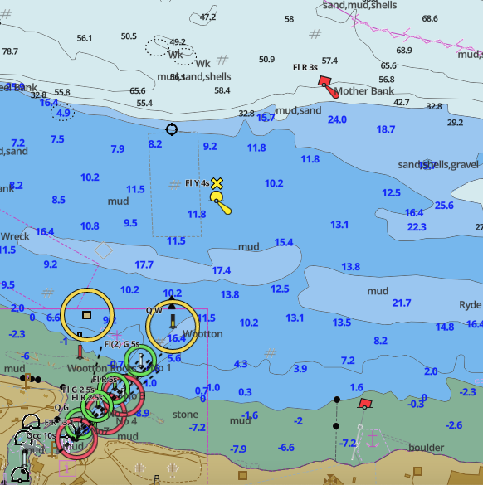
Committee Boat
Quarr no 5A

A2.1 The committee boat will be midway between Mother Bank and Quarr no 5A buoys.
A2.2 Start Line between the Committee Boat at 50 45’.05N, 01 11’.50W and Quarr no 5A buoy (fl Y 4s) 50 45’.01N, 01 11’.89W.

Appendix 3 FINISH LINE

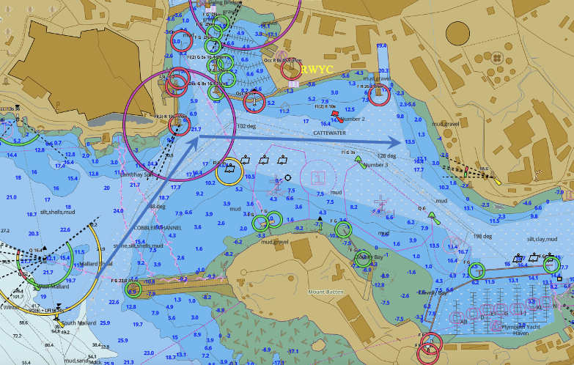

A 3.1 Enter Plymouth Sound via the Western Entrance to cross the finish line off the RWYC by sailing in an easterly direction to pass an extension of a transit from the RWYC Flag staff and a yellow and black striped transit staff on the shore below it. The outer distance limit of the line will be the mooring buoys on the south side of the main Cattewater channel.

A3.2 Record Finish Time and pass race declaration to race control..

Appendix 4 COMMUNICATIONS

Supplied to all entrants at registration.

Amendment 1

3.3 The following OSR have been modified:
- Regulation 3.07.3 (Escape Hatches - multihulls) modified in NoR 6.6.1.
- Regulation 3.29.13 (AIS) extended in NoR 6.6.2.
- Regulation 4.01.2 (Sail Number) extended in NoR 11.
- Regulation 5.01 (Lifejacket) extended in NoR 6.6.3.

6 OTHER CONDITIONS
6.1 Flying drones or other small unmanned aircraft is strictly forbidden for all competitors, including any supporting vessels, between 1300BST and 1500BST on the day of the race within an area 1 mile to the North, South, East and West of the Starting line.

17 TIME LIMIT

17.1 The race time limit is 1000 BST on Thursday 28th July. Boats that have not crossed the finish line by this time will not be given a finishing time.

Amendment 2
    - The race will start under numeral flag 1.

