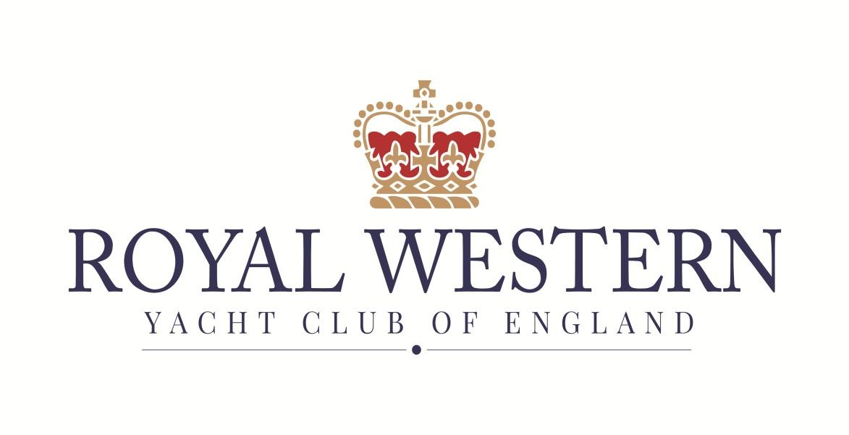
Autumn Series
Icicle Series

NOTICE OF RACE

Sunday mornings
11th September to 18th December 2022
Autumn Series: 11th Sept to 30th Oct
Icicle Series: 6th Nov to 18th Dec

Organising authority: Royal Western Yacht Club of England Ltd, Plymouth, UK

NOTICE OF RACE

1 RULES
  - The Series will be governed by the rules as defined in The Racing Rules of Sailing.
  - Where there is a conflict between the Notice of Race and the Sailing instructions, the Sailing Instructions shall prevail.
1.2 Where boats are racing within the boundaries of the Port of Plymouth they are referred to the Dockyard Port of Plymouth Order 2020, a copy of which is displayed on the Club notice board, (website https://www.legislation.gov.uk/uksi/2020/1261/made ) and Local Notices to Mariners. When the Race Committee believes that such regulations have been broken so as to bring the sport into disrepute it will act under RRS 60.2(c) requesting the Protest Committee to act under RRS 69.1(a), Allegation of Misconduct.
1.3 The Post-Race Penalty and RYA Hearing/Arbitration of the RYA Rules and Disputes procedures will be available. This is the preferred method of resolving disputes. See the official website for details. See: https://www.rya.org.uk/racing/rules/rules-disputes
1.4 Racing rule(s) 35, 44, A2, will be changed in the sailing instructions.
1.5 Under RRS 87, IRC Rule 22.4.2 is replaced with:
“The maximum number of crew that may sail aboard a boat shall be the crew number printed on the certificate plus one. There is no weight limit.”
2 SAILING INSTRUCTIONS & CLASS SPLITS
2.1 The Sailing Instructions will be available on the Series Events Web Pages on the club website no later than Monday 4th April 2022. All classes will start and race as one fleet, unless numbers dictate that it will be necessary to split the fleet.
3 COMMUNICATION
3.1 The official notice boards shall be https://rwyc.org/club-racing/autumn-series/ and https://rwyc.org/club-racing/icicle-series/ for Autumn Series and Icicle Series respectively.
3.2 While racing., except in an emergency, a boat shall not make voice or data transmissions and shall not receive voice or data communication that is not available to all boats. This restriction also applies to mobile telephones. Race Control will operate on Channel 77.
4 ELIGIBILITY AND ENTRY
4.1 Both series are open to all monohull and multihull boats that hold ether a current IRC or MOCRA rating certificate. All boats will also be dual scored using the National Handicap for Cruisers scheme (NHC). Unrated boats may enter the NHC series alone.
4.2 Ratings are only valid from the date of issue on the certificate.
4.3 Ratings may be varied during the Series.
4.4 Eligible boats may enter by completing the online entry form. Entry forms are available at: https://rwyc.org/club-racing/autumn-series/ and https://rwyc.org/club-racing/icicle-series/ for Autumn Series and Icicle Series respectively.
4.5 A yacht’s racing result will only be accepted when a fully completed entry form (either on-line or paper) and payment has been received by race administration at the RWYC prior to racing. All entries must comply with RRS 75 (Race Entry & Qualification).

5 FEES
5.1 Entry fees are as follows:
 | RWYC Members | Non -Members
Autumn Series (11Sept – 30 Oct) | £50 | £80
Icicle Series (6 Nov – 18 Dec) | £40 | £60
Individual day | £10 | £15

5.2 To qualify for a RWYC Members race entry, the boat shall be owned or chartered by an RWYC member who shall be on board for each leg of the race. Evidence of this may be required by the Race Committee (RC).
6 CREW LIMITATIONS
6.1 Under RRS 87, IRC Rule 22.4.2 is replaced with:
“The maximum number of crew that may sail aboard a boat shall be the crew number printed on the IRC certificate plus one. There is no weight limit.”
7 ADVERTISING
7.1 Boats may be required to display advertising chosen and supplied by the organizing authority

8 SCHEDULE
8.1 Dates of racing:
Autumn Series, Sunday mornings, 11th September to 30th October (8 mornings)
Icicle Series, Sunday mornings, 6th November to 18th December (6 mornings)
No racing will be held on Sunday 13th November (Remembrance Sunday)
8.2 Number of races:
2 races are scheduled each day for all classes, at the discretion of the Race Officer.
8.3 The scheduled time of the warning signal for the first race of each day is 1025.

9 THE COURSES
9.1 If two races are held, the first will be a short windward/leeward course. The second race will be either another windward/leeward, or a Round the Cans (RTC) course. The course to be sailed for the ‘Round the Cans’ race will be detailed in the sailing instructions.
9.2 Where appropriate, the race committee may ‘average lap’ slower boats.
10 PENALTY SYSTEM
10.1 The Post-Race Penalty and the RYA Arbitration system of the RYA Rules and Disputes procedures will be available. This is the preferred method of resolving disputes. See https://www.rya.org.uk/racing/rules/rules-disputes
10.2 Discretionary penalties will be available to the Protest Committees (PC).

11 SCORING
11.1 Each boat’s series score will be the total of her race scores less one discard for each four (4) races completed. This changes RRS A2
11.2 Where a One Design class totals 5 or more, they will continue to be scored within their rated fleet and scored separately as an individual class with prizes awarded as per NoR 15.
12. RISK STATEMENT
12.1 RRS 4 states: “The responsibility for a boat’s decision to participate in a race or to continue racing is hers alone.”
Sailing is by its nature an unpredictable sport and therefore inherently involves an element of risk. By taking part in the event, each competitor agrees and acknowledges that:
(i) they are aware of the inherent element of risk involved in the sport and accept responsibility for the exposure of themselves, their crew and their boat to such inherent risk whilst taking part in the event;
(ii) they are responsible for the safety of themselves, their crew, their boat and their other property whether afloat or ashore;
(iii) they accept responsibility for any injury, damage or loss to the extent caused by their own actions or omissions;
(iv) their boat is in good order, equipped to sail in the event and they are fit to participate;
(v) the provision of a race management team, patrol boats and other officials and volunteers by the organiser does not relieve them of their own responsibilities;
(vi) the provision of patrol boat cover is limited to such assistance, particularly in extreme weather conditions, as can be practically provided in the circumstances;
(vii) it is their responsibility to familiarise themselves with any risks specific to this venue or this event drawn to their attention in any rules and information produced for the venue or event and to attend any safety briefing held at the venue;
(viii) they are responsible for ensuring that their boat is equipped and seaworthy so as to be able to face extremes of weather; that there is a crew sufficient in number, experience and fitness to withstand such weather; and that the safety equipment is properly maintained, stowed and in date and is familiar to the crew.
(ix) their boat is adequately insured.
13 INSURANCE
Each participating yacht shall be insured with valid third- party liability insurance with a minimum cover or the foreign equivalent for the duration of the race or series.

14 PRIZES
Prizes will be given as follows:
At the discretion of the Race Committee a daily prize may be awarded to each class after the days racing when five (5) or more boats in that class have taken part.
Overall and Part Series awards will be presented as follows -
Up to 5 entrants – 1 prize; 6 to10 entrants – 2 prizes; over 11 entrants – 3 prizes.
A trophy will be awarded to the overall winner in each class.
All boats sailing under IRC/VPRS will be ‘dual scored’ under NHC. Daily prizes may be awarded for IRC or VPRS, but prizes may also be awarded based on all NHC results.

15 FURTHER INFORMATION
For further information please contact:
The Secretary,
Royal Western Yacht Club,
Queen Anne’s Battery PL4 0TW
Email: admin@rwyc.org

End

