Autumn Series (11th Sept -30th Oct)
Icicle Series (6th Nov – 18th Dec)

Sailing Instructions

Sunday mornings

11th September to 18th December 2022

Organising authority: Royal Western Yacht Club of England Ltd
Plymouth UK

Competitors and their families are invited by the Flag Officers of The Royal Western Yacht Club to be temporary members of the Club on Sundays for the duration of the regatta and to make full use of the bar, and catering facilities.

SAILING INSTRUCTIONS
1 RULES
1.1 The Series will be governed by the rules as defined in The Racing Rules of Sailing.
1.2 Where boats are racing within the boundaries of the Port of Plymouth they are referred to the Dockyard Port of Plymouth Order 2020, a copy of which is displayed on the website (https://www.gov.uk/government/groups/qhm-plymouth and Local Notices to Mariners. When the Race Committee believes that such regulations have been broken so as to bring the sport into disrepute it will act under RRS 60.2(c) requesting the Protest Committee to act under RRS 69.1(a), Allegation of Misconduct.
As a naval/commercial port, shipping movements are frequent and have priority. Boats must at all times keep clear of ships leaving or entering the port and must obey instructions from the Race Committee where avoiding action is necessary. Failure to obey Race Committee instructions may be treated as misconduct.
1.3 An engine or other alternative means of propulsion shall be used when appropriate to avoid risk of collision with another vessel that is underway but not racing, or in a grave emergency. The facts shall be reported by radio to the Race Committee at the finish with written details submitted to the race office before the end of protest time. The protest committee may impose a penalty if it thinks fit. This changes RRS 63.1.
1.4 Racing rule(s) 35, 44 & A2 will be changed as follows:
Rule 35: Time Limit –The time limit for the first boat (other than MOCRAS) will be 75 minutes and 90 minutes for W/L and RTC courses respectively. The time limit for the first MOCRA is 120 minutes for the first boat. The race will be abandoned if no boats have finished within this time.
Rule 44.1: For all classes, RRS 44.1 is changed so that the Two Turns Penalty is replaced by the One Turn Penalty.
Rule A2: Each boat’s series score will be the total of her race scores less one discard for each four (4) races completed.
1.5 Under rule 87, rule(s) IRC Rule 22.4.2 of the IRC class rules is replaced with:

“The maximum number of crew that may sail aboard a boat shall be the crew number printed on the certificate plus two. There is no weight limit.”

1.6 For safety reasons, no boats shall race with anchors mounted on, or in front of, their stem-head rollers or other bow fittings.

2 NOTICES TO COMPETITORS

2.1 Notices to competitors will be posted on the RWYC Autumn Series and Icicle Series event pages. https://rwyc.org/autumn-series/ and https://rwyc.org/icicle-series/ respectively These shall be deemed to be the Official Notice Boards.

3 CHANGES TO SAILING INSTRUCTIONS

3.1 Any amendments to the sailing instructions will be posted on the RWYC website www.rwyc.org - Autumn Series or Icicle Series event pages at least twenty-four (24) hours before it will take effect.
4 SIGNALS MADE ASHORE

4.1 Signals made ashore will be displayed at the RWYC Flagstaff. Notices to competitors will be posted on the website event pages and additionally may be displayed on the noticeboard in the clubhouse.
5 SCHEDULE OF RACING and COURSES
5.1 Dates of racing:
a) The Autumn Series will be held every Sunday morning from 11th September 2022 to 30th October 2022 incl.
b) The Icicle Series will be held every Sunday morning from 6th November 2022 to 18th December 2022 inc. There will be no racing on Sunday 13th November (Remembrance Sunday)
5.2 IRC and NHC classes will sail windward – leeward courses (designation W) finishing at the committee boat line, and/or ‘round the cans’ courses (designation C) finishing at the RWYC line (see SI 13.2). It is intended that two (2) races will be sailed per morning.

5.3 MOCRA Class; will sail one round the cans race, starting 10 minutes before the other classes. Courses will be displayed on the side of the committee boat using the marks specified on the chartlet in Appendix A.
5.4 The scheduled time of the warning signal for the first race each day is 1010hrs for MOCRA class and 1025 for the other classes.
6 CLASS FLAGS & SIGNALS
6.1 It is scheduled that the first warning signal will be given at 1010 for MOCRA Class and 1025 for IRC/ NHC Classes. The second race will begin as soon as practically possible after the completion of the first race.
6.2 Class Flags shall be flown from the backstay when racing as follows.
Class | Class Flag
MOCRA | 8
IRC & NHC | 1

7. RACING AREAS

7.1 Windward – leeward course - Course boards on the side of the committee vessel will display the course letter of the windward mark and the leeward mark (see Appendix A). All racing will usually take place north of Plymouth Breakwater. The Race Committee reserves the right to stage racing south of the breakwater if required.

7.2 The MOCRA class will use navigation marks which may be both north and south of Plymouth Breakwater in accordance with the chartlet in Appendix A.

7.3 Round the Cans course (IRC & NHC Classes) – the committee boat will display letter boards indicating the course configuration in accordance with the chartlet in Appendix A.

7.3 All courses to be sailed for all fleets will be announced before each class warning signal on Ch 77. Failure to receive a VHF message shall not constitute grounds for redress

8 DESCRIPTION OF MARKS

8.1 Committee boat Start Pin – Orange Pillar Buoy

8.2 Committee Boat Finish Pin – as above (same mark).

9 THE START

9.1 All boats shall pass close to the Committee vessel on the side opposite to the start line before the warning signal of the first race of each day with mainsails hoisted for identification.

9.2 The start line for all classes will be between the mast displaying an orange flag on the Committee vessel and the outer distance mark, an orange pillar buoy.

9.3 Boats whose warning signal has not been made shall stay at least 100 metres from the starting area.

10 RECALLS (This changes rule 29.2)

10.1 In the event of an individual recall, competitors’ attention may be brought to the signal on VHF Ch 77. Such communication may not be transmitted until one minute after the start. The failure to receive any Race Committee transmissions shall not constitute grounds for redress.

11. CHANGE OF COURSE

11.1 Courses will not be changed after the start signal. Courses for each class will be displayed on the side of the committee boat.

12 SHORTEN COURSE

12.1 Windward/leeward courses can only be shortened after more than one lap has been sailed. Round the cans races may be shortened at any mark.

13. THE FINISH

13.1 Windward/leeward (W/L) races shall finish by sailing directly back through the start line after rounding the leeward mark. Where more than one lap is signaled, boats shall sail through the start line on each lap.

13.2 Round the Cans (RTC) races will finish at the RWYC club line, unless shortened course is signaled, by sailing in an easterly direction to pass an extension of a transit from the RWYC flag mast and a yellow and black striped transit staff on the shore below it. The outer distance limit of the line will be the yacht mooring buoys on the south side of the main Cattewater channel.

13.3 The MOCRA Class will record their own finish times using a Finish Line between NW Winter and NE Winter. These times must be sent using either VHF 77, by email to admin@rwyc.org or by telephone to the club 01752 660077, as soon as possible.
13.4 Whilst racing, boats are prohibited from entering the Controlled Mooring Area located north of Mountbatten peninsula and south of the Plym navigation channel. Boats must remain north of a line extending from the westerly mooring buoy positioned on the south side of the Plym navigation channel, east through each mooring buoy on the northern boundary of the Controlled Mooring Area and west of a line extending from the most westerly mooring buoy on the south side of the Plym navigation channel, due south to the Mountbatten peninsula.

The prohibited area defined above ranks as an obstruction to sea room under RRS.

14 THE PENALTY SYSTEM
14.1 The Exoneration Penalty and RYA Arbitration of the RYA Rules and Disputes procedures will be available. This is the preferred method of resolving disputes.
See also 1.4.
15 PROTESTS

The protest time limit is 60 minutes after the last boat has finished the last race of the day. The same time limit applies to protests by the race committee and protest committee about incidents they observe in the racing area and to requests for redress.

16 RETIREMENT

16.1 Boats retiring shall report their retirement to the Race Committee as soon as possible but no later than 60 minutes after finishing or retiring.

16.2 Retirements shall be reported via VHF Ch 77 to the Committee Vessel, or by telephone to RWYC telephone: 01752 660077

17 TIME LIMIT (see also SI 1.4)

17.1 For W/L and RTC races the time limits for the first boat shall be 75 minutes and 90 minutes respectively.

17.2 For MOCRA’S the time limit will be 120 minutes (2 hours).
17.3 All boats not finishing within 30 minutes and 60 minutes for W/L and RTC races respectively of the second boat in their class will be scored DNF. The race committee may advise competitors of the expiry of the time limit on VHF 77
18 SCORING
18.1 Each boat’s series score will be the total of her race scores less one discard for every four races.

19 RADIO COMMUNICATIONS

19.1 All yachts shall carry and operate a VHF radio and monitor Race Committee broadcasts.

19.2 The Race Committee will use VHF Ch 77 or advise an alternative channel if this is not available..

19.3 The failure to receive any Race Committee transmissions shall not constitute grounds for redress.

20 RISK STATEMENT

Sailing is by its nature an unpredictable sport and therefore inherently involves an element of risk. By taking part in the event, all competitors agree and acknowledge that:
- they are aware of the inherent element of risk involved in the sport and accept responsibility for the exposure of themselves, their crew and their boat to such inherent risk whilst taking part in the event;
- they are responsible for the safety of themselves, their crew, their boat and their other property whether afloat or ashore;
- they accept responsibility for any injury, damage or loss to the extent caused by their own actions or omissions;
- their boat is in good order, equipped to sail in the event and they are fit to participate;
- the provision of a race management team, patrol boats and other officials and volunteers, by the organizer does not relieve them of their own responsibilities;
- the provision of patrol boat cover is limited to such assistance, particularly in extreme weather conditions, as can be practically provided in the circumstances;
(vii) it is their responsibility to familiarise themselves with any risks specific to this venue or this event drawn to their attention in any rules and information produced for the venue or event and to attend any safety briefing held at the venue;

21 INSURANCE

21.1 Each participating boat is required to hold adequate insurance and in particular to hold insurance against third-party claims in the sum of at least £3m.

End

APPENDIX A

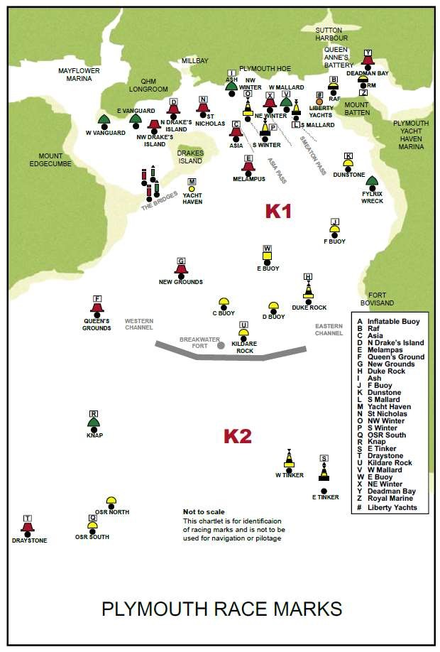
Force 4

F
ORCE

4

